UNEARTHING THE ENVIRONMENTAL IMPACT OF HUMAN ACTIVITIES:A GLOBAL CO2 EMMISSION ANALYSIS

A PROJECT REPORT

Submitted by

G.HARITA KUMARI(TL) 222000946

R.DHAARANI 222000944

R.DIVYA 222000945

- JAISEE RANI 222000947

PROJECT INCHARGE:DR.YUVARANI C
ASSISTANT PROFESSOR
DEPARTMENT OF MATHEMATICS
DRBCCC HINDU COLLEGE
PATTABIRAM,CHENNAI-72

CONTENTS

- INTRODUCTION

  - Overview

  - Purpose

2.PROBLEM DEFINITION & DESIGN THINKING

2.1 Empathy map

2.2 Ideation and brainstorming map

3.RESULT

- ADVANTAGES & DISADVANTAGES

- APPLICATIONS

- CONCLUSION

- FUTURE SCOPE

1.INTRODUCTION

  - Overview

Global warming is one of the biggest challenges currently beihave faced by the human race, although correlation is not causation, a likely cause of global warming is due to increased atmospheric carbon dioxide from human activities. CO2 Emission refers to the Carbon Dioxide emitted throughout the world. For this analysis we will be focusing on CO2 Emissions and its effect on the world we live in as well as some key factors and stats that may play a role in the emission of CO2 globally. Fossil fuel use is the primary source of CO2. The data throws light onto how much fossil fuels are burnt, per year per nation, which amounts to an increase in CO2 every year. This will help researchers and environment experts to predict global warming. So countries should set a goal to decrease this amount yearly.

Analysing Global Co2 Emission across countries from 1975 to 2020. This dataset contains a record of Co2 Emission by each Country and Region of Earth, here we are going to analyse and visualise Country wise, Region wise and Overall Co2 Emission on Earth

Technical Architecture:

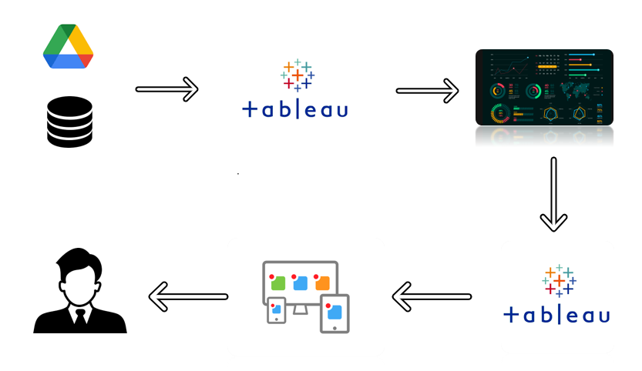

  - Purpose

Carbon dioxide emissions are the primary driver of global climate change. It’s widely recognised that to avoid the worst impacts of climate change, the world needs to urgently reduce emissions. But, how this responsibility is shared between regions, countries, and individuals has been an endless point of contention in international discussions.
This debate arises from the various ways in which emissions are compared: as annual emissions by country; emissions per person; historical contributions; and whether they adjust for traded goods and services. These metrics can tell very different stories.

2.PROBLEM DEFINITION &
DESIGN THINKING

2.1 Empathy Map

An Empathy Map is used to help understand and empathize with the perspective of a particular user or customer.It is a visual representation of the user’s attitude ,behaviors,emotions,and experiences that can be used to gain a deeper understanding of their needs and motivations.The Empathy Map is typically divided into four quadrants:“Says”,“Thinks”,“Does”and“Feels”.In each quadrant,the user’s thoughts,feelings,actions and spoken words are recorded to help build a more complete understanding of their perspective.The Empathy Map is often used in design thinking and user experience to help inform the design of products or services that better meet the needs of the user

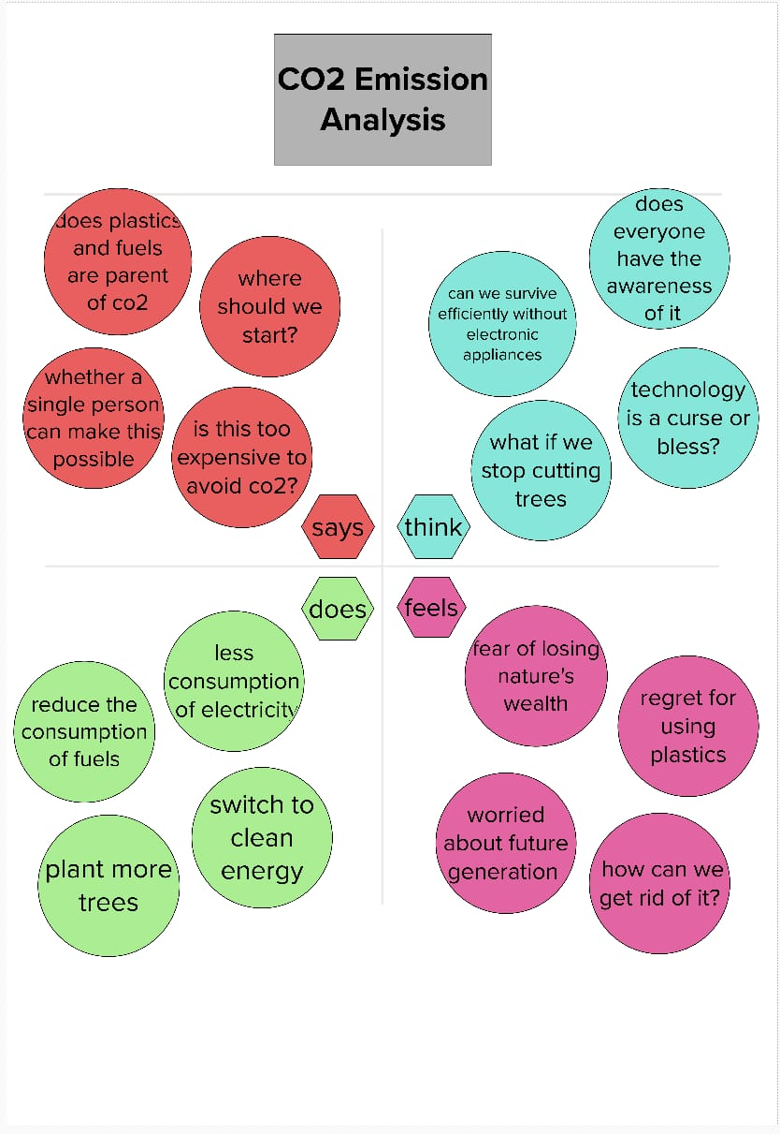

2.2 Ideation & Brainstorming Map

Brainstorming provides a free and open environment that encourages everyone within a
team to participate in the creative thinking process that leads to problem solving. Prioritizing volume over value, out-of-the-box ideas are welcome and built upon, and all participants are
encouraged to collaborate, helping each other develop a rich amount of creative solutions.

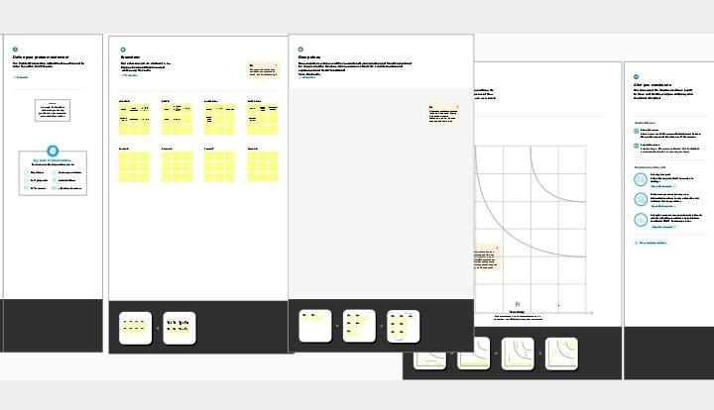

3.RESULT

Data visualization

Preparing the data for visualization involves cleaning the data to remove irrelevant or missing data, transforming the data into a format that can be easily visualized, exploring the data to identify patterns and trends, filtering the data to focus on specific subsets of data, preparing the data for visualization software, and ensuring the data is accurate and complete. Since the Data is initially pre-processed we can skip this step. Basically this process helps to make the data easily understandable and ready for creating visualizations to gain insights into the performance and efficiency.

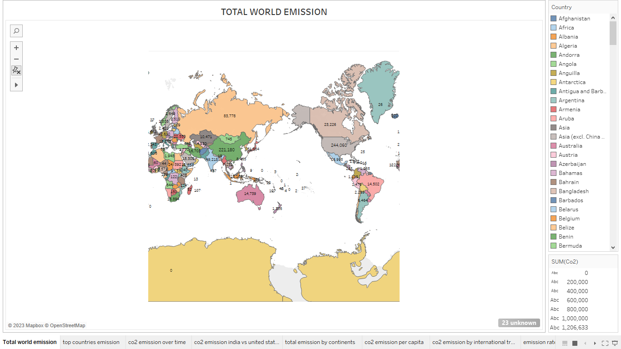

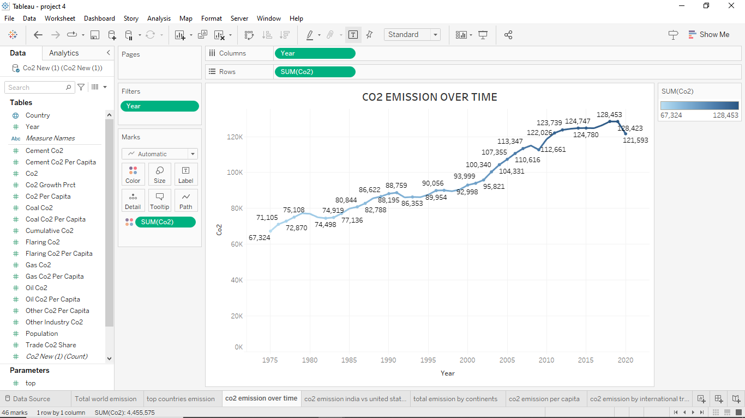

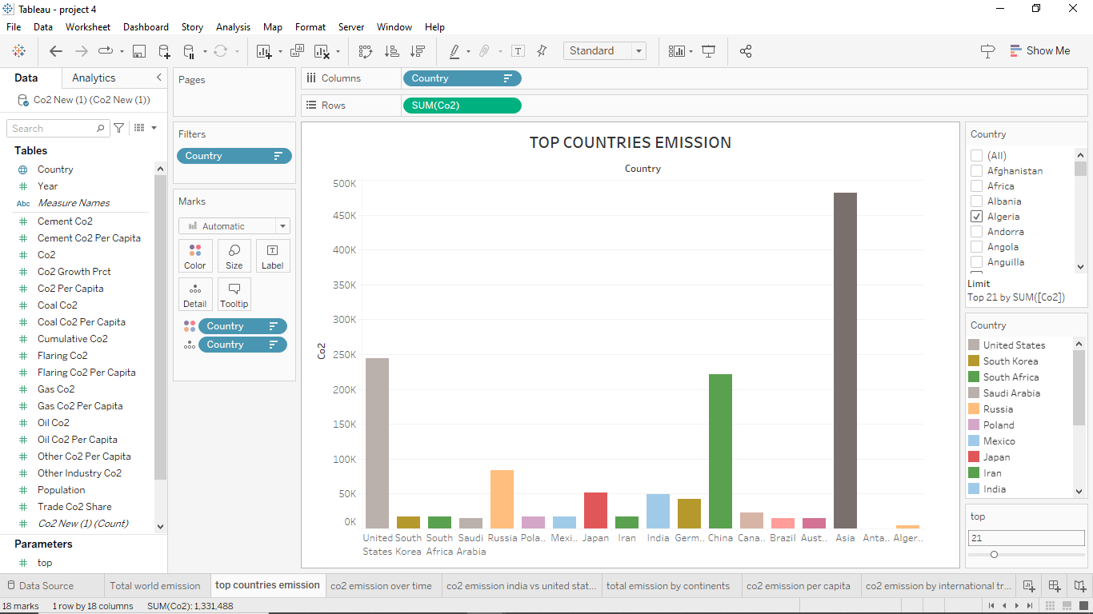

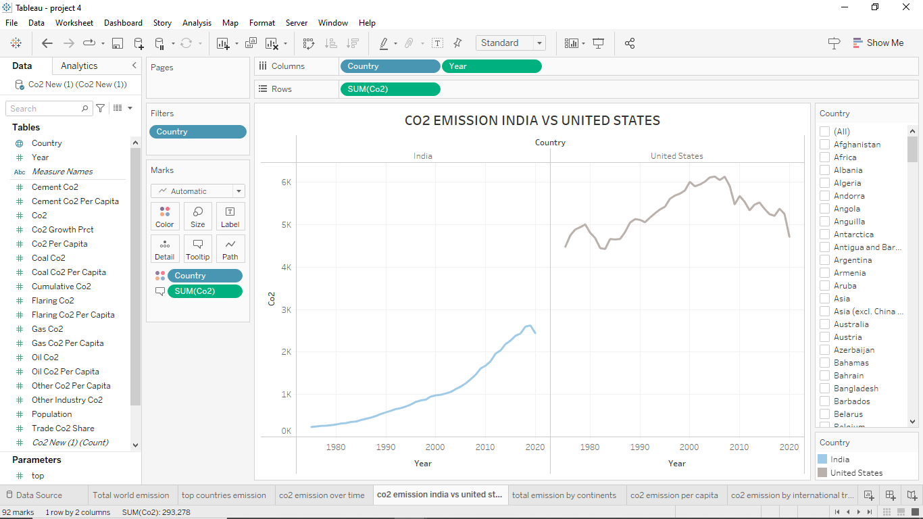

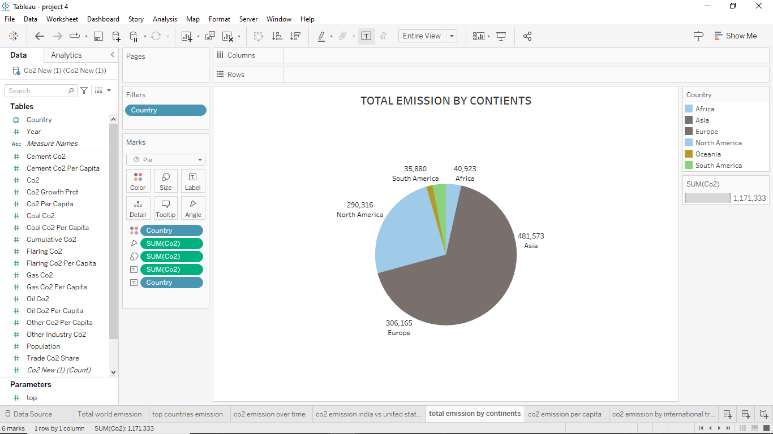
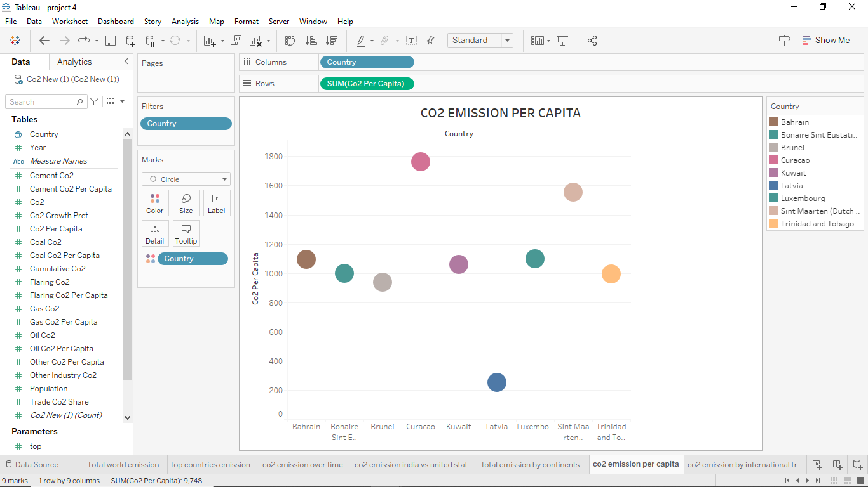

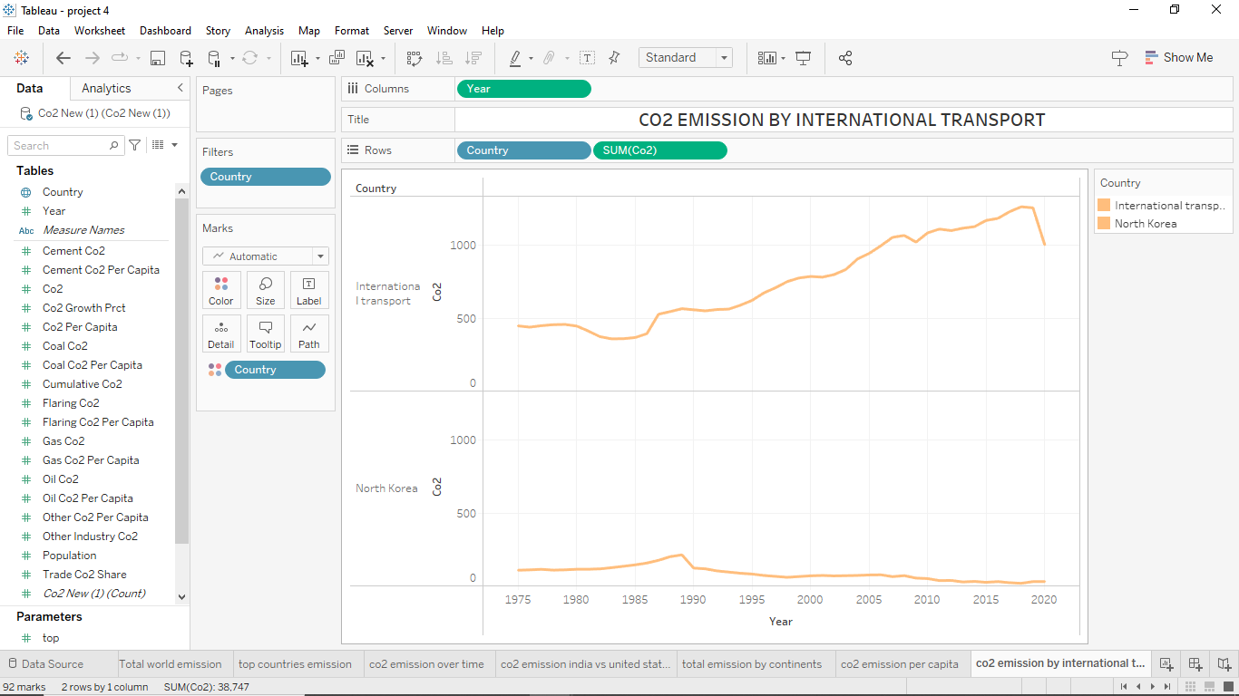
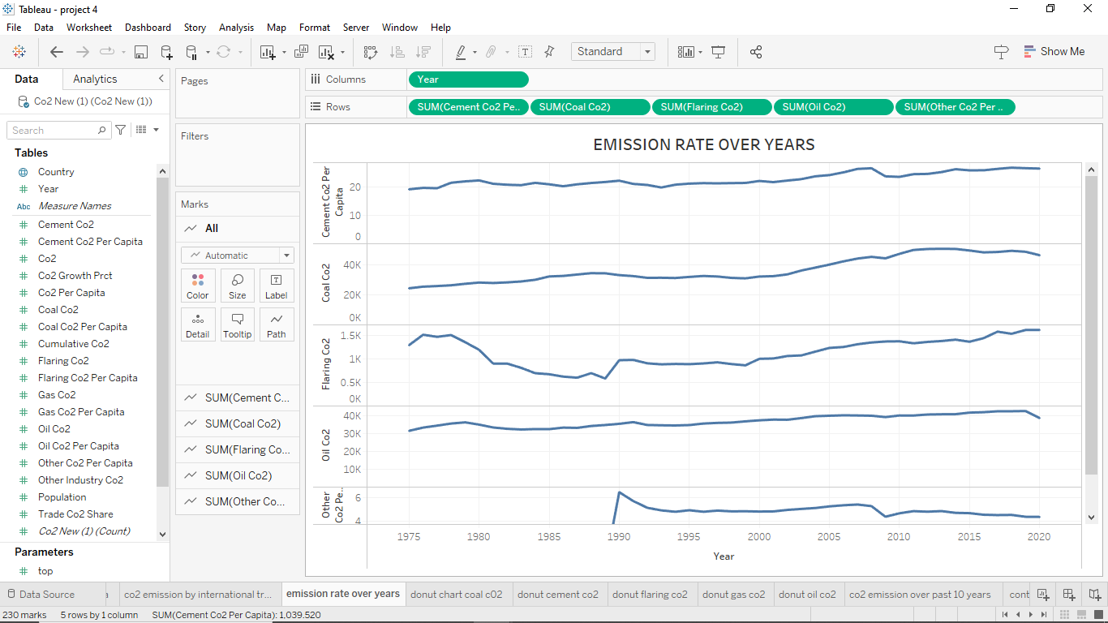

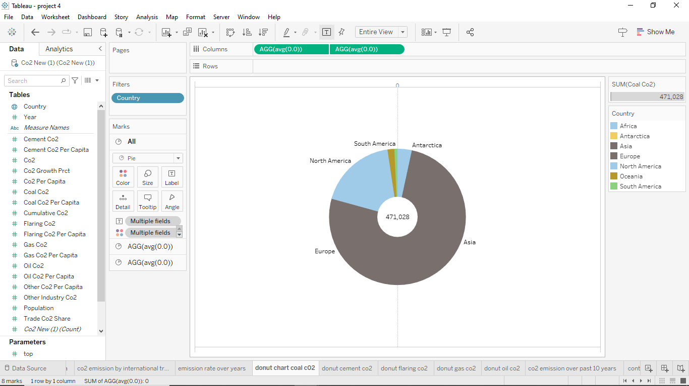
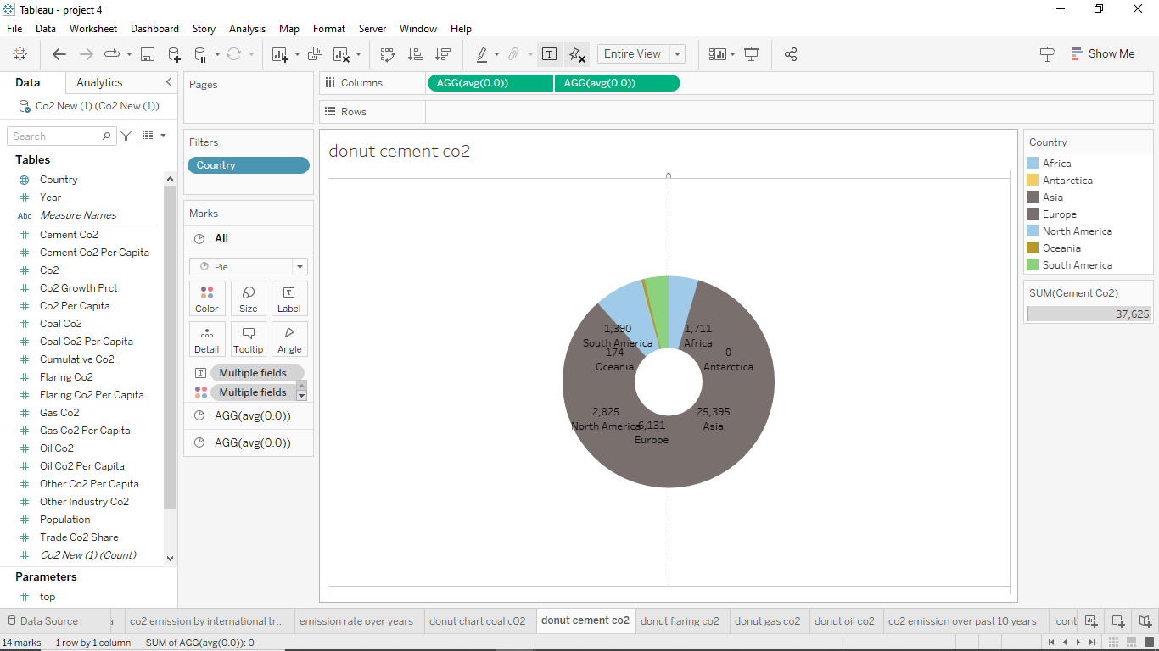

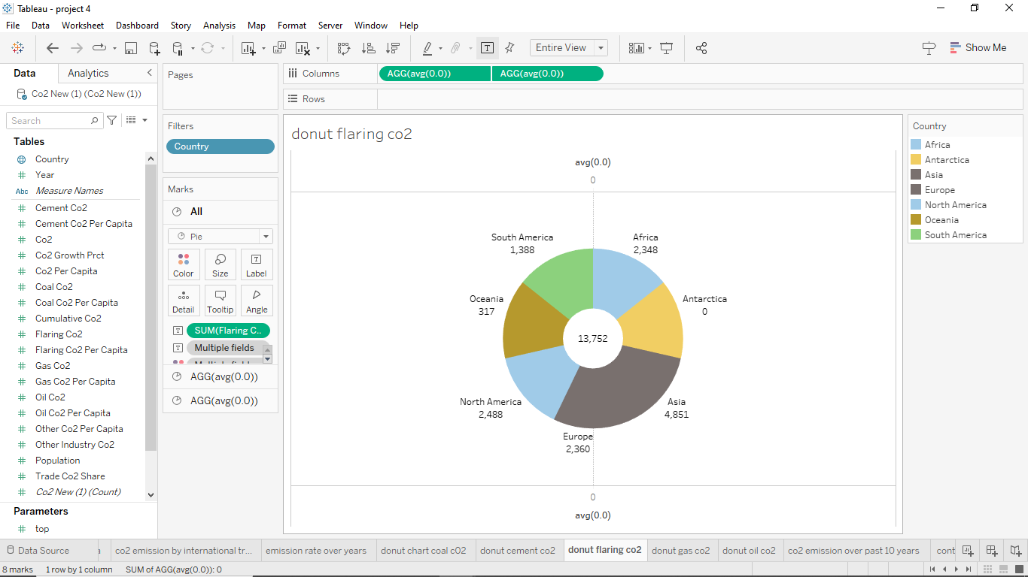
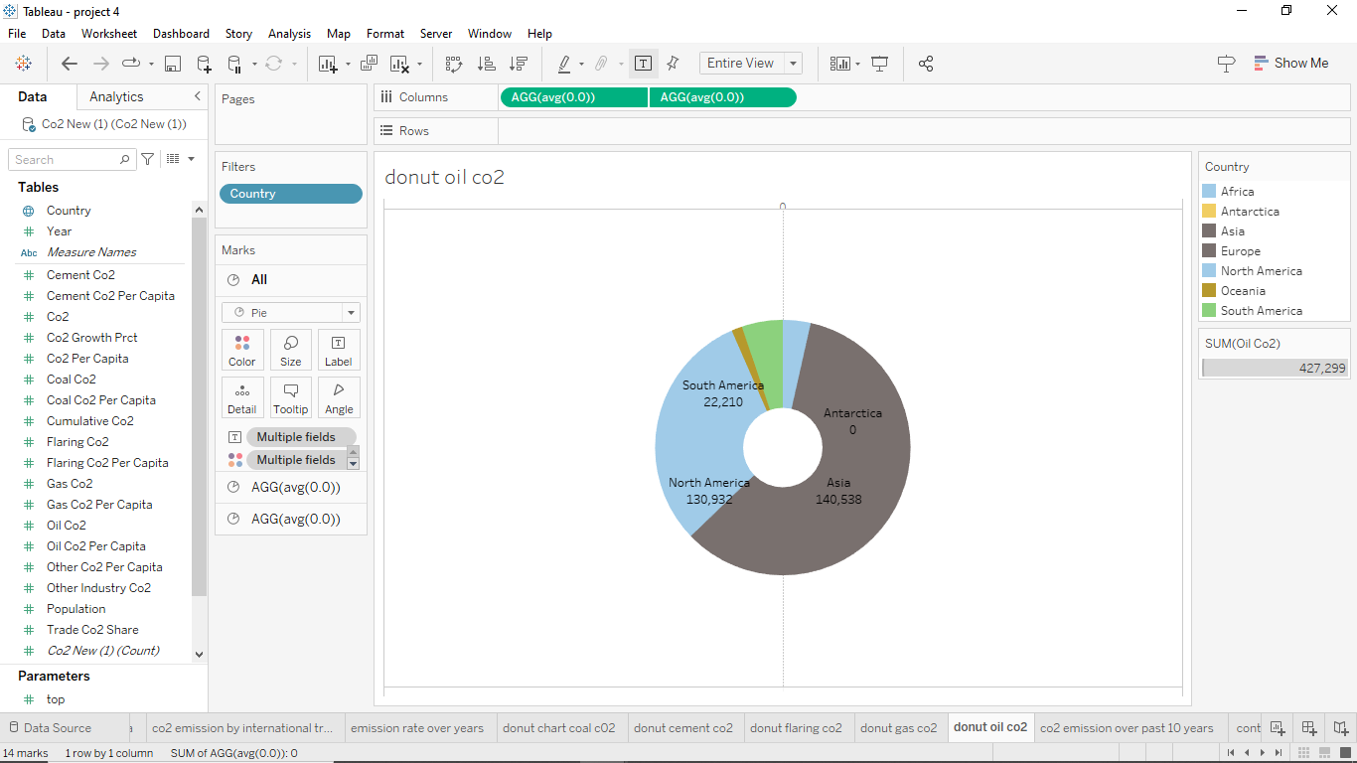

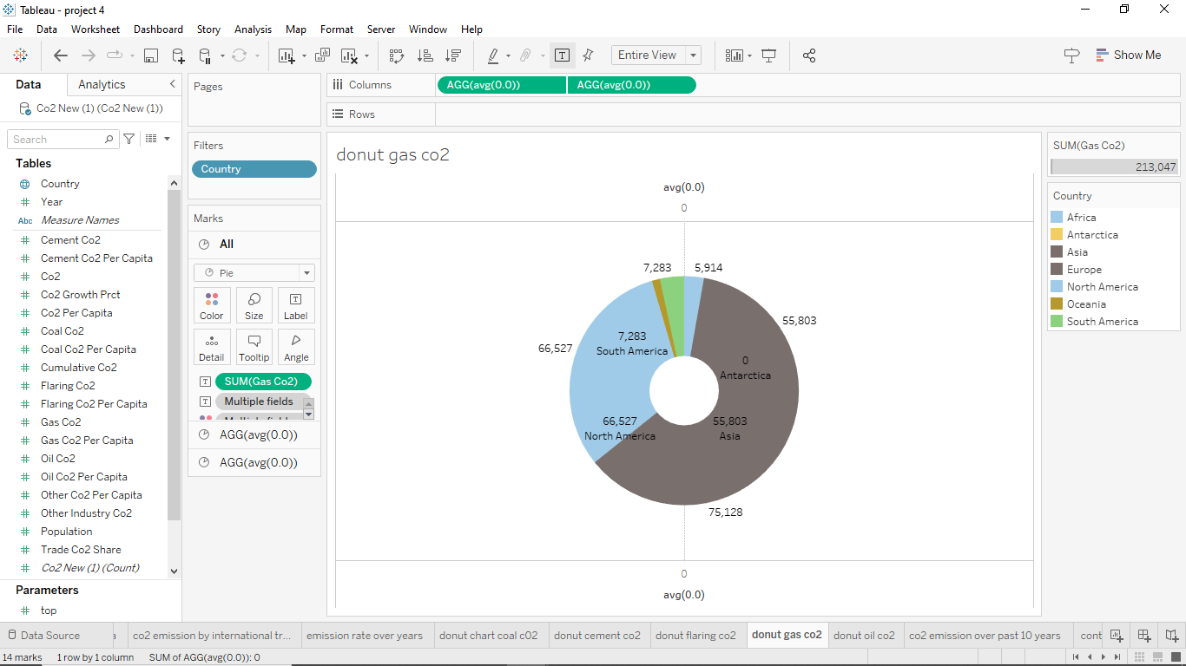
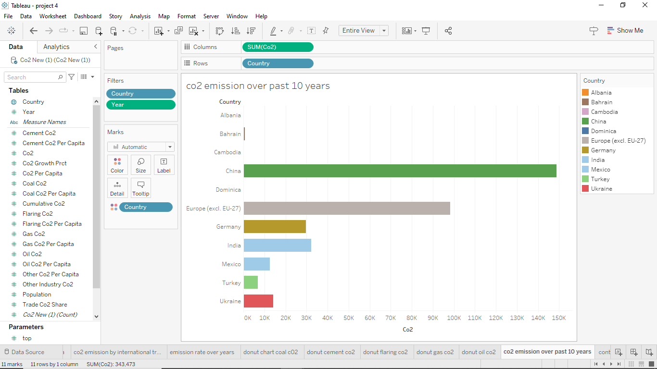

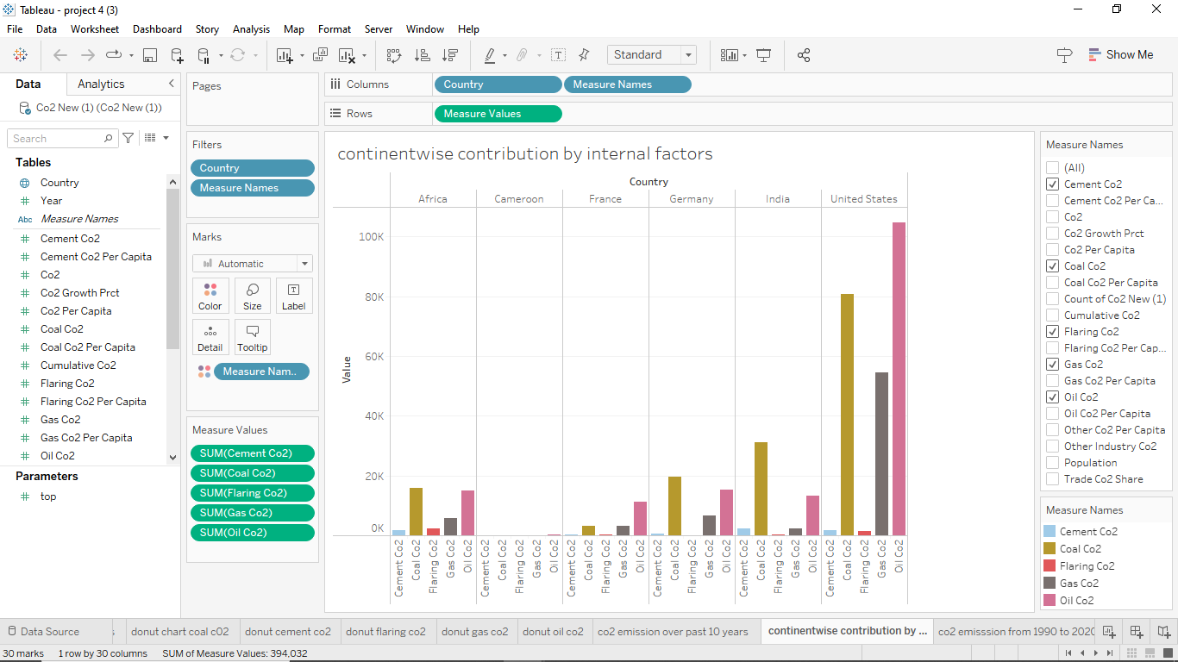
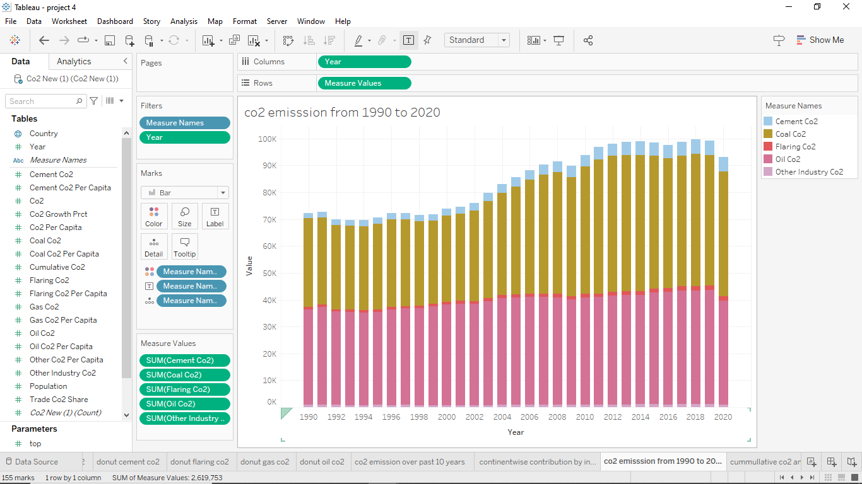

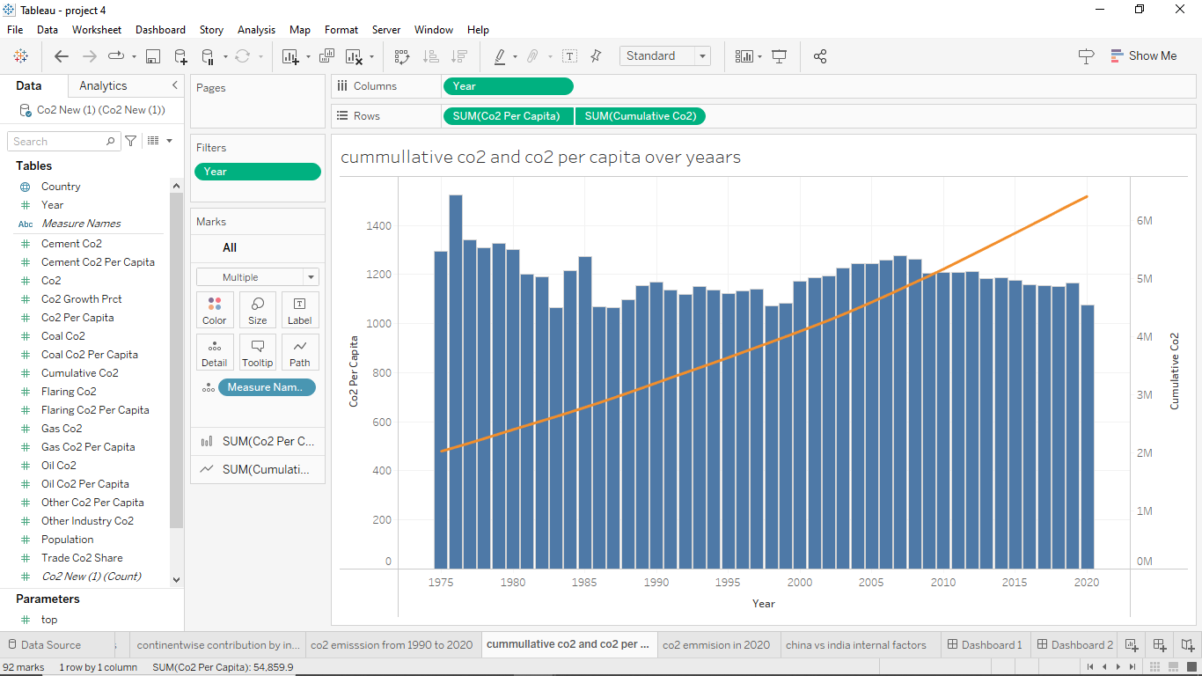
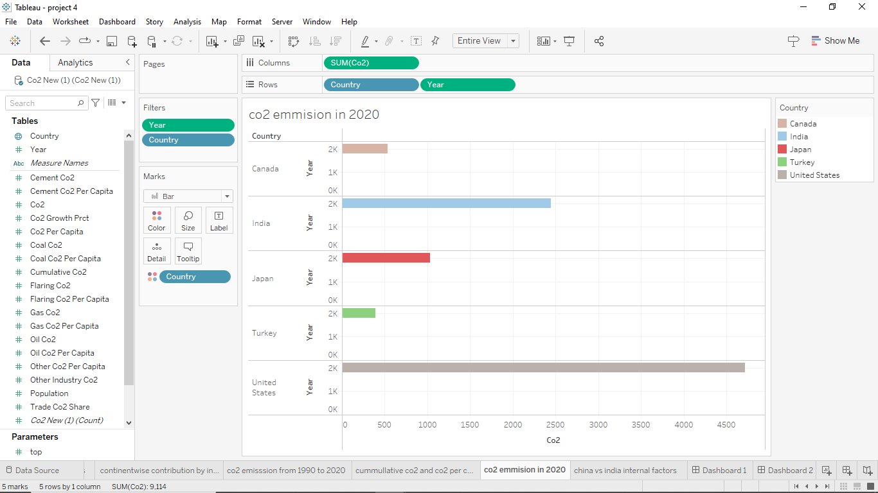

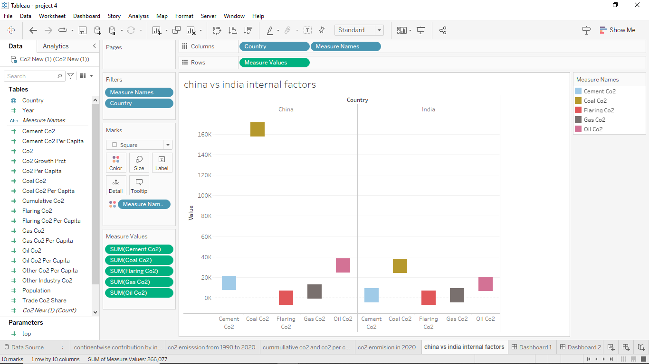

Dashboard

A dashboard is a graphical user interface (GUI) that displays information and data in an organized, easy-to-read format. Dashboards are often used to provide real-time monitoring and analysis of data, and are typically designed for a specific purpose or use case. Dashboards can be used in a variety of settings, such as business, finance, manufacturing, healthcare, and many other industries. They can be used to track key performance indicators (KPIs), monitor performance metrics, and display data in the form of charts, graphs, and tables.

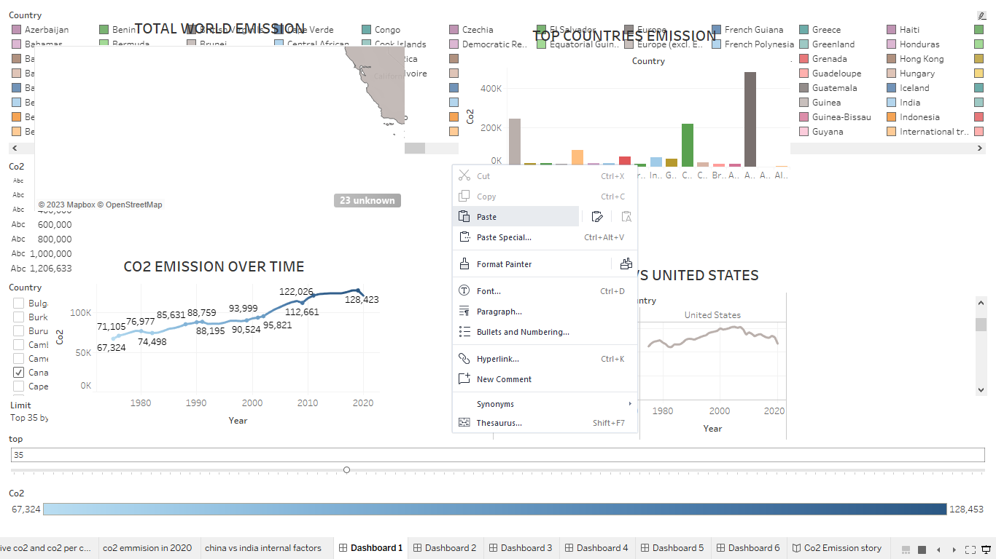
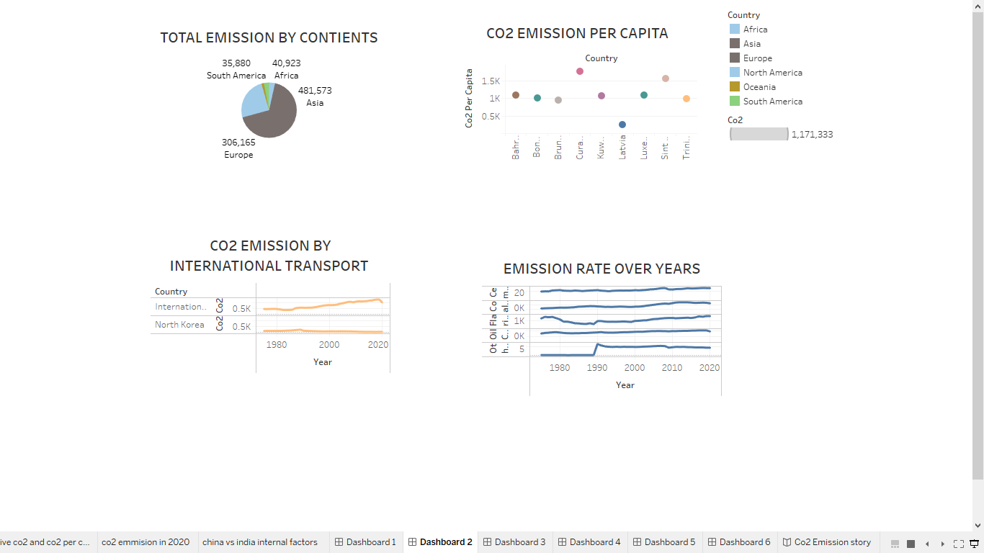

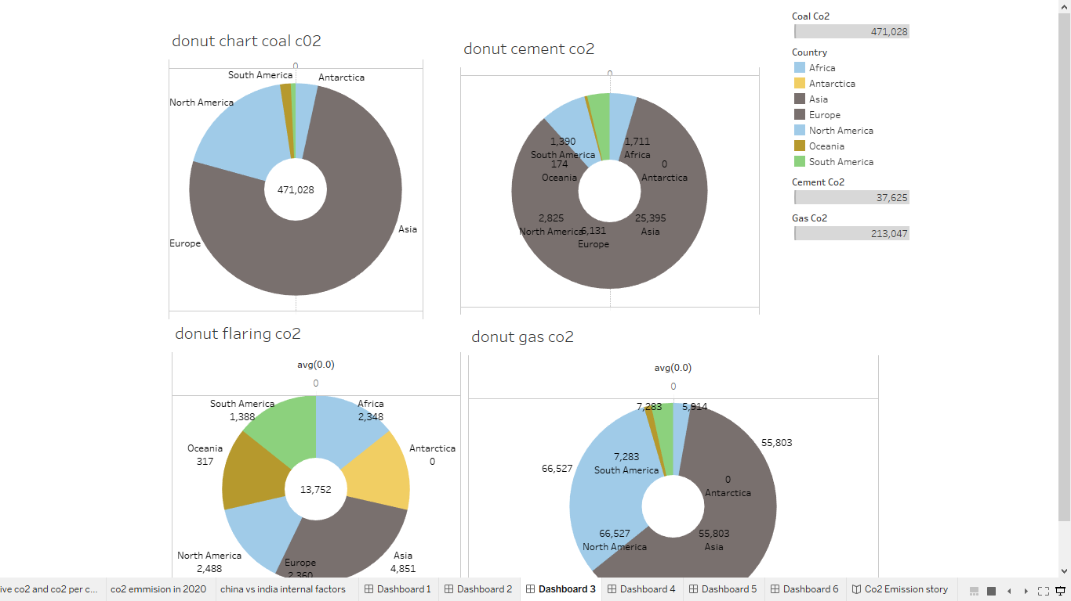
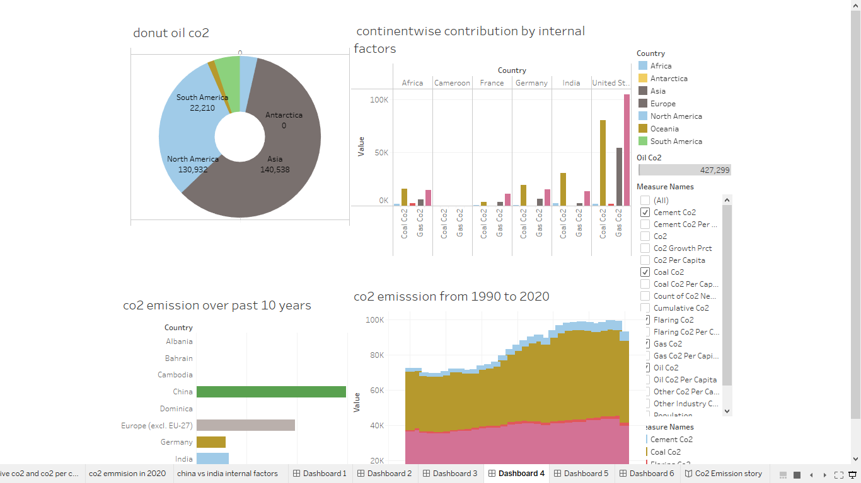

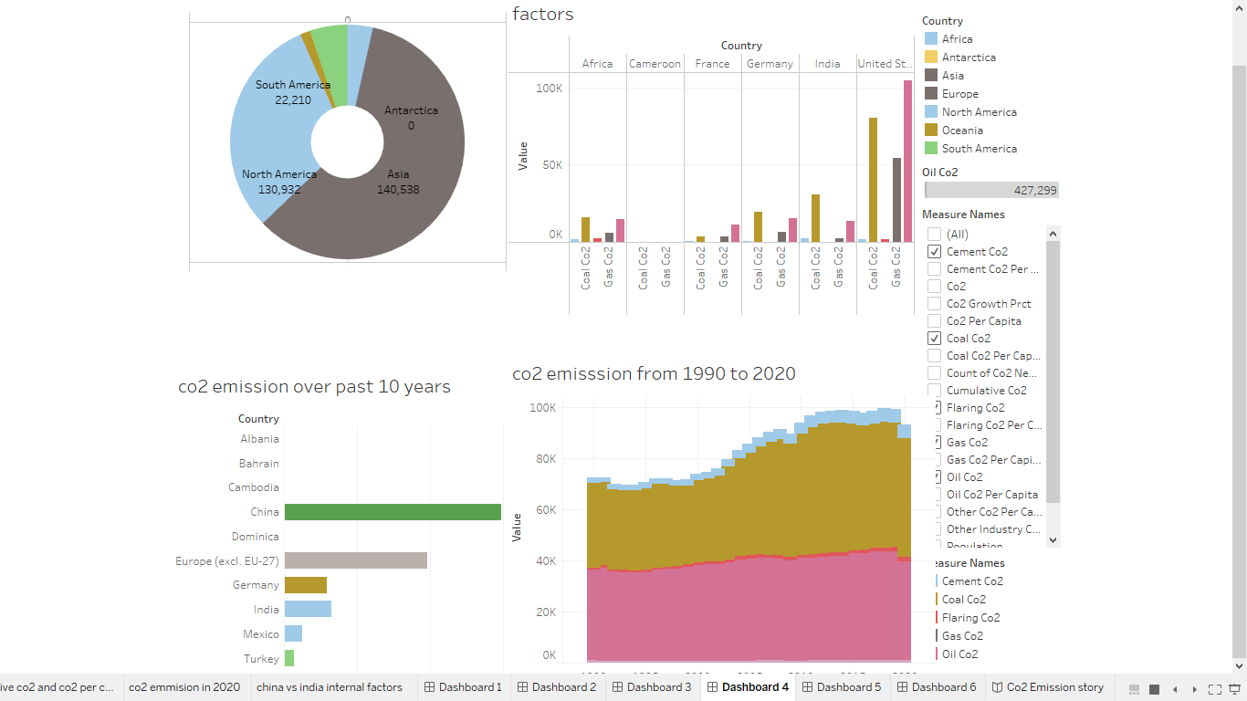

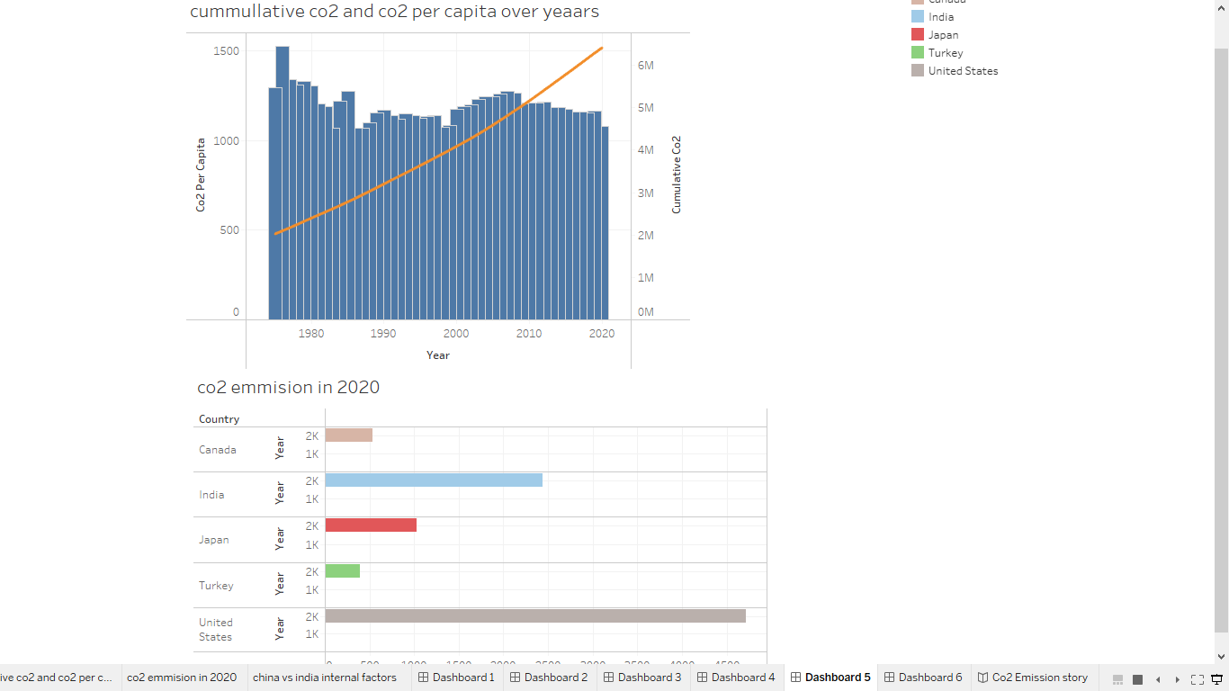

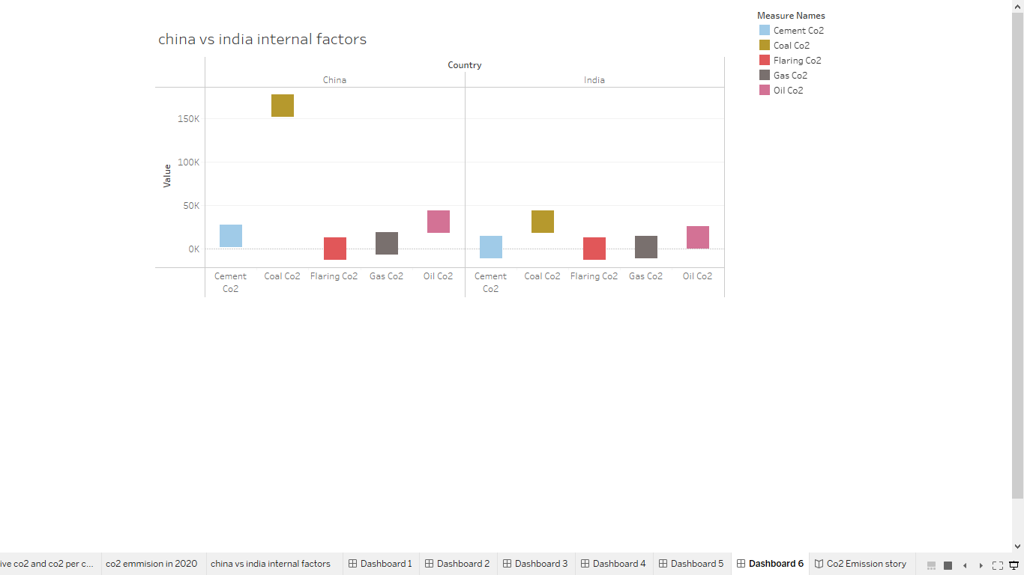

Co2 Emission story

A data story is a way of presenting data and analysis in a narrative format, with the goal of making the information more engaging and easier to understand. A data story typically includes a clear introduction that sets the stage and explains the context for the data, a body that presents the data and analysis in a logical and systematic way, and a conclusion that summarizes the key findings and highlights their implications. Data stories can be told using a variety of mediums, such as reports, presentations, interactive visualizations, and videos.

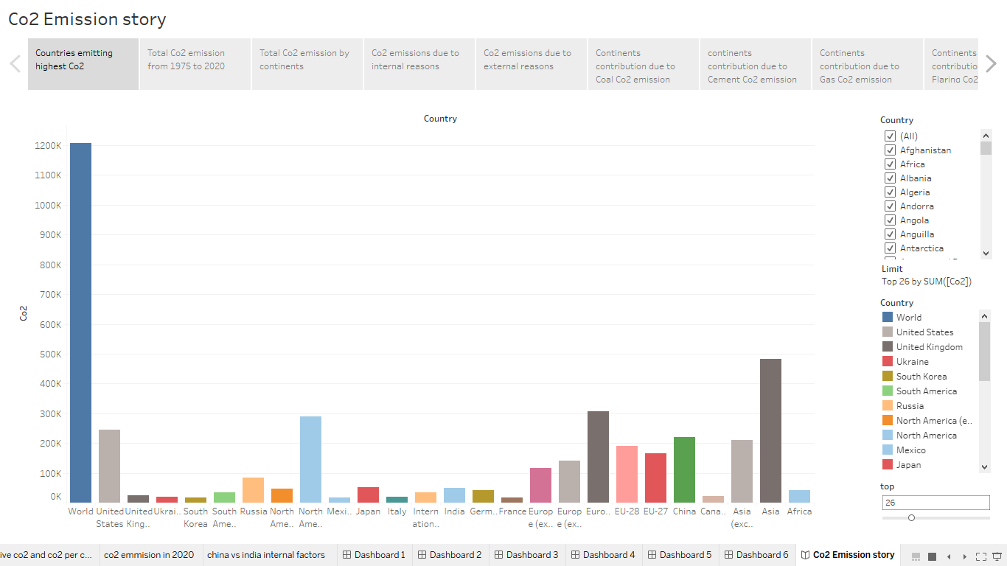

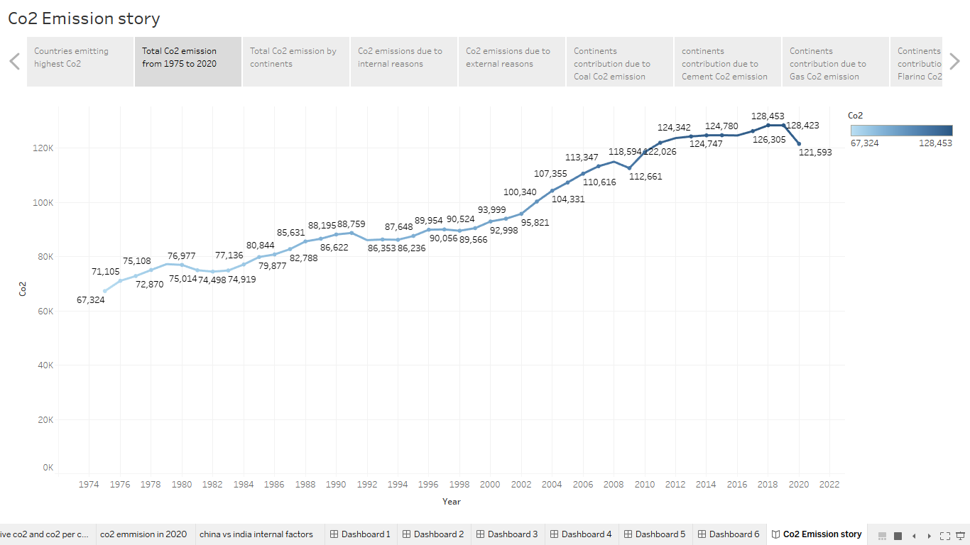

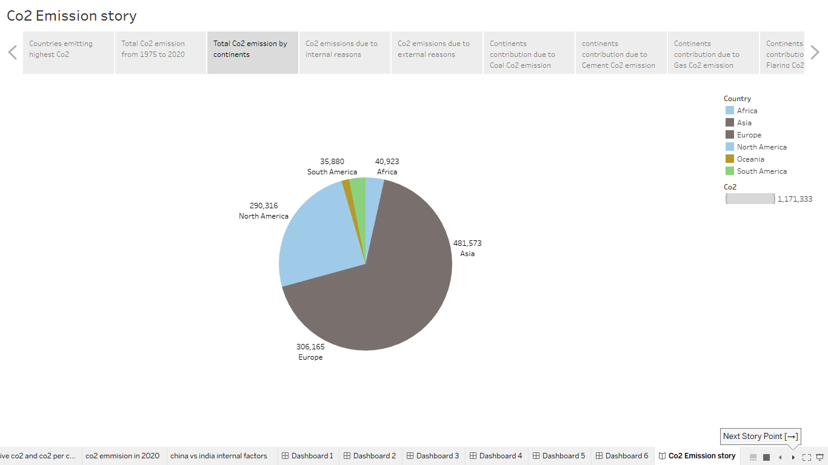
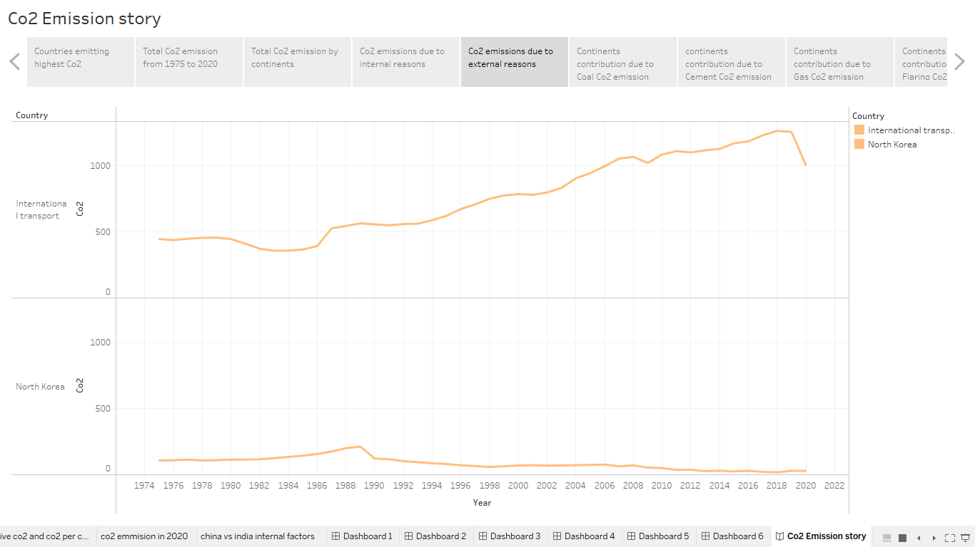

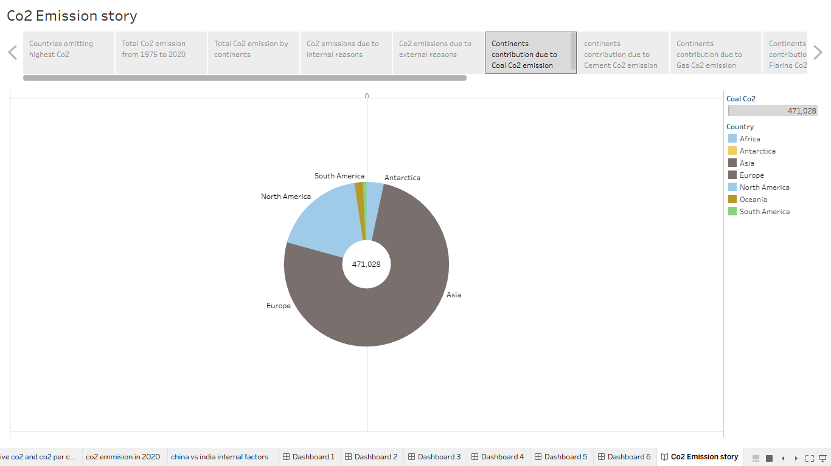
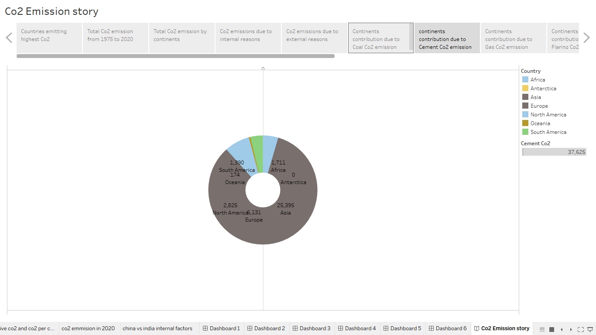

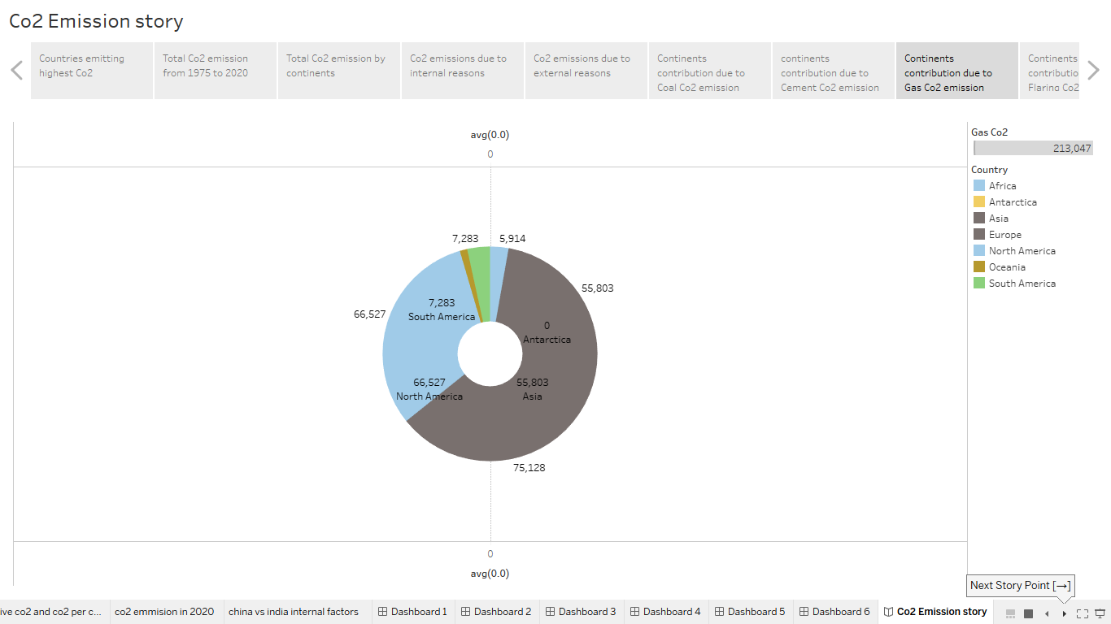
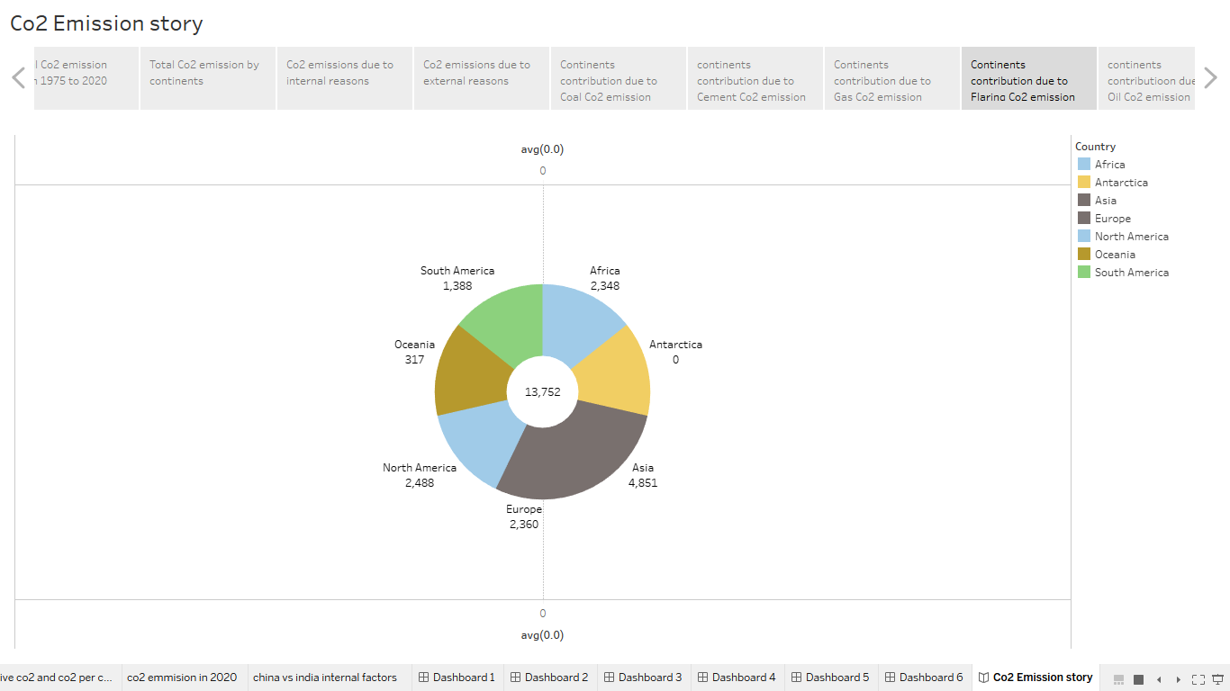

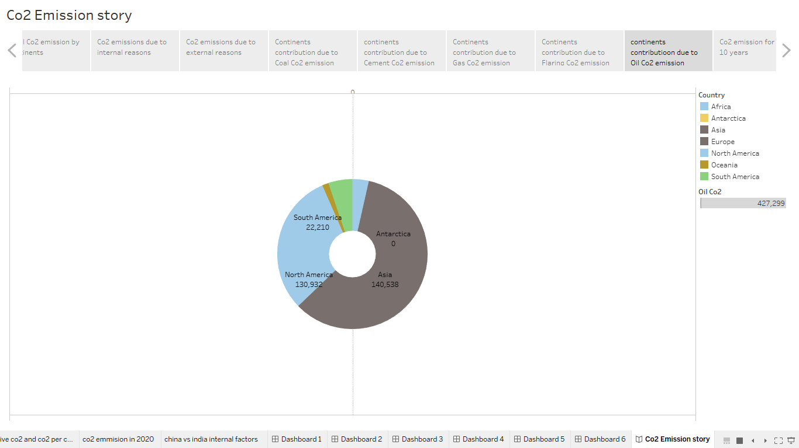
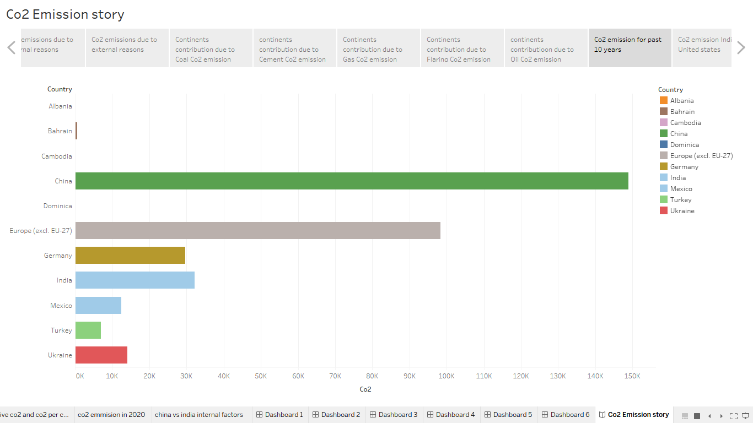

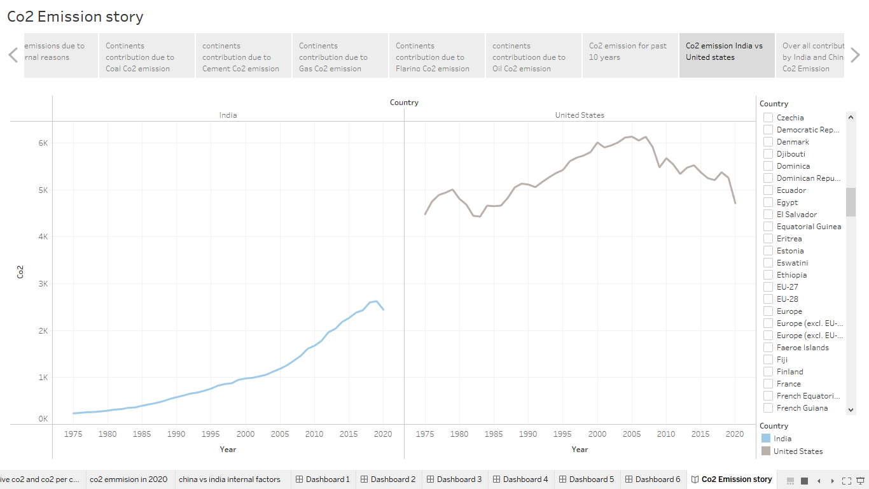

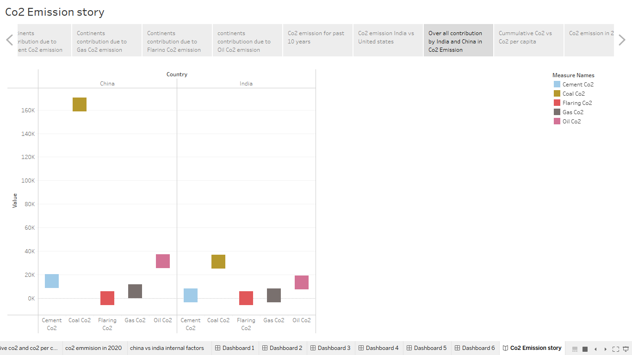

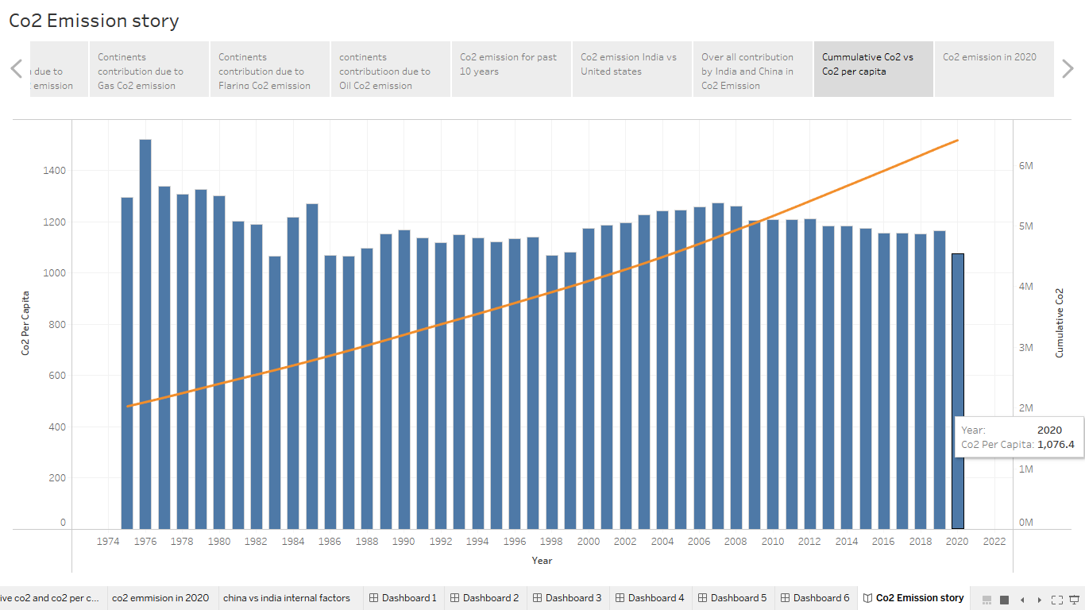

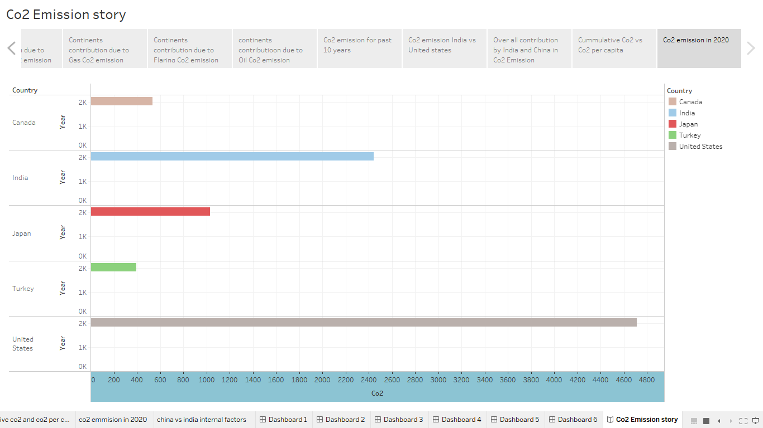

Web Integration

Publishing helps us to track and monitor key performance metrics, to communicate results and progress. help a publisher stay informed, make better decisions, and communicate their performance to others.

- ADVANTAGES &
DISADVANTAGES

Advantages

Developing nations in Asia, Africa, and Latin America will need enormous increases in low-cost energy to power their economic development and lift their citizens out of poverty. Fossil fuels— notably coal, natural gas, and oil—which currently supply more than 80 percent of the world’s energy, will remain indispensable. As countries grow more affluent, they will also acquire greater means to reduce pollution. Indeed, it is precisely the wealth unleashed by industrialization that enables societies to invest in modern technologies and other practices that clean up the environment. Further, the best available evidence suggests that current levels—and forseeable future increases—of carbon dioxide are not only harmless, but are indeed beneficial to plants and humans. Quixotic policies to supposedly limit global warming, by making fossil fuels prohibitively expensive, would condemn much of humanity to wretched conditions unimaginable in developed nations.

Disadvantages

The challenge in sustainably advancing the building sector is the increasingly large outflows of CO2 due to the utilization of non-sustainable energy sources in the planning, construction, and operations of buildings [9]. CO2 is also emitted from the broad utilization of land in the urbanization process [11]. The energy sourced from fossil fuels is non-sustainable, and yet it accounts for a large percentage of the energy used in the construction and operation processes. Sustainable or renewable energy sources only account for 6% of the total energy used in the sector, while fossil fuel used in construction activities accounts for 40% of worldwide greenhouse gas emissions. Although numerous novel methods have been proposed to lessen the CO2 footprint of buildings, particularly in high-density urban communities, the challenge has yet to be solved appreciably [14]. The utilization of a non-sustainable energy source directly affects the environment, and it is directly proportional to the amount used. The construction of a building emits CO2, both directly and indirectly. Direct CO2 emissions originate from the burning of natural gas, diesel, light fuel oil, and other oil-based commodities, while indirect CO2 emissions come from the application of electricity. Globally, the indirect CO2 emission accounts for 85% of the total CO2 emitted, while only 14% is from direct emissions. Sustainaty 2020, 12, 7427 3 of 11 The

2030 Climate and Energy Framework states that 27% of energy should be sourced from sustainable energy sources, while energy efficiency or productivity should increase by 27% [15]. However, there are challenges in finding sustainable solutions to low productivity and efficiency. One solution is to itemize the processes of construction and operation so that detailed evaluations can be carried out. Construction includes the assembly of the building material, the development of the structure and foundation, and the transportation and operation of machinery. The procedure comprises the maintenance aspect of the building and its infrastructure. The evaluation of the life cycle requires a detailed inventory of these processes in all phases of the building’s life. The assessment would highlight strategies that could be made more productive and efficient.

5.APPLICATIONS

The range of potential CO2 use applications is very large and includes direct use, by which CO2 is not chemically altered (non-conversion) and the use of CO2 by transformation (via multiple chemical and biological processes) to fuels, chemicals and building materials (conversion) (Figure 2).
Although most conversion pathways are highly energy-intensive and still in their infancy, they are attracting growing interest and support from governments, industry and investors. Companies such as CarbonCure and Solidia, which use CO2 to manufacture concrete, have recently attracted investment from Breakthrough Energy Ventures and OGCI Climate Investments, respectively. In North America, the NRG COSIA Carbon XPrize is supporting the development of novel CO2 use opportunities with a USD 20 million global competition 12. Governments in Canada, Japan, the United Kingdom and the United States as well as the European Commission are also providing significant RD&D support for CO2 use.
The emerging interest in opportunities for the use of CO2 is driven by several concerns. Key among these is its potential to contribute to climate goals. Other factors include technology leadership, energy security, the anticipated availability of cheap and abundant renewable energy (which could make CO2 conversion routes more economical), and the potential for the use of CO2 to be either a stepping stone or a smaller-scale alternative to carbon capture and storage (CCS).
In select cases, such as building materials, the use of CO2 can be based on purely commercial drivers as it delivers a product with superior performance and lower cost than conventionally produced building materials. CO2 could be an important raw material for products that will continue to require carbon, either because it provides their structure and properties (carbon-containing chemicals) or because the use of carbon-free energy carriers, such as electricity or hydrogen, is challenging (for example, aviation fuels). CO2 is one of few alternatives to fossil fuel as a source of carbon.

- CONCLUSIONS

Carbon emission research has received increasing global attention due to rapid global climate change. Thus, academics, international organizations, and government agencies have paid special consideration to identifying the carbon emission sources and thereby implementing various carbon mitigation strategies. The initial research on carbon emissions was conducted in 1981 and the domain has evolved significantly over the past two decades. This study provides a scientometric analysis of carbon emission research using 2561 bibliographic records extracted from the WoS core collection database. Several scientometric analysis, such as co-authorship, author co-citation, document co-citation, and journal co-citation analysis were utilized to identify and explore the trends in carbon emission research.
Research publication trend analysis revealed a steady increase in carbon emission research publications. Accordingly, the year 2018 was identified as the most productive year of publications, with a record of all-time high 443 publications. It is expected that the year 2019 will record an even higher number of publications as more and more researchers are now focusing on this important issue. As for the most productive authors on carbon emission research, several Chinese authors topped the list. While Yong Geng and Yi-Ming Wei were recognized as the most prolific authors in the domain, H. Scott Mathews was recognized as the only non-Chinese author among the top ten authors in the domain. The Peoples Republic of China, the USA, and England emerged as the most productive countries on carbon emission research. In terms of betweenness centrality, the USA topped the list, which indicated that the USA have had better research collaborations and links compared to other countries. On the contrary, betweenness centrality of China was low despite being the top publishing country. In addition, several Chinese institutions topped the list of the most productive institutions, which was led by the Chinese Academy of Sciences, Tsinghua University and the University of Chinese Academy of Sciences. In terms of centrality, the University of Cambridge, University of Leeds and University of Colorado held the top positions. It is evident that despite the high number of publications, China is not recording good research connections with other countries on this domain. It was clear that the majority of the carbon emission research studies were conducted in developed countries. As a result of this, scientometric analysis returned most of the results related to carbon emissions based on the developed countries. However, the lack of studies on developing countries has resulted in bringing more attention to global researchers towards addressing this issue in developing countries.
Several core journals have published the most significant research studies on carbon emissions such as Energy Policy and Journal of Cleaner Production. These journals also received high citation frequencies as well as citation bursts making them the most prolific journals on carbon emission research. In terms of document co-citation analysis results, the publications by Eggleston HS and Weidema BP received the highest number of co-citations. Moreover, Solomon S and Finkbeiner M recorded significant citation bursts on carbon emission research. Most significantly, several citation bursts were recorded between 2010 and 2014, which indicate that more and more authors are focusing on carbon emission research since 2010. Additionally, IPCC and Wiedmann T topped the list of most cited authors in the domain.
According to the results observed through the scientometric analysis, it is evident that the carbon emission research domain has attracted the attention of global researchers. A significant increase in research publications over the past two years is a strong indication of the growth in the carbon emission research domain. Carbon capturing, predicting future carbon emissions through trend analysis, evaluating carbon performance, identifying carbon mitigation opportunities and ultimately achieving zero carbon emission goals are some of the most popular research areas in the carbon emission research domain. The scientometric analysis revealed the trends of carbon emission research over the past three decades which was the objective of this research.
There are certain limitations of this review which should be taken into consideration by the readers. Firstly, this paper was based only on the literature data obtained from the WoS core collection which might not cover all the available literature on the domain. Although many authors have used the WoS database, the comprehensive nature of this database cannot be assured. Moreover, data were only obtained from the journal articles which might not capture all the literature available on carbon emissions. It should also be noted that since the data obtained from the WoS core collection were filtered using the title, studies which might not reflect the carbon emission related work in the title were not included. However, this scientometric analysis provides a reflection of the global carbon emission research for researchers, government institutions and practitioners. It offers an in-depth understanding and a valuable insight into the most significant authors, institutions, countries in the carbon emission research domain as well as the trends of publications. The findings of this study can be used to obtain the necessary support and guidance to formulate carbon emission control policies.

7.FUTURE SCOPE

The IEA draws upon a wide range of respected statistical sources to construct estimates of energy demand, energy-related CO2 and other greenhouse gas emissions for the year 2022. Sources include the latest monthly data submissions to the IEA Energy Data Centre, real-time data from power system operators across the world, statistical releases from national administrations, and recent data from the IEA Market Report series that covers coal, oil, natural gas, renewables, electricity and energy efficiency. Where data are not available on an annual or monthly basis, estimates are used.
The scope of CO2 emissions in this report includes emissions from all uses of fossil fuels for energy purposes, including the combustion of non-renewable waste, as well as emissions from industrial processes such as cement, iron and steel, and chemicals production. Estimates of industrial process emissions draw upon the latest production data for iron and steel, clinker for cement, aluminium, and chemicals. CO2 emissions from the combustion of flared gases are also included in estimates of global energy-related greenhouse gas emissions.
Non-CO2 greenhouse gas emissions include fugitive emissions from oil, gas and coal supply. Methane and nitrous oxide emissions related to energy combustion are also evaluated, based on typical emissions factors for the corresponding end uses and regions. When converting non-CO2 greenhouse gas emissions to equivalent quantities, a global warming potential over a 100-year period is used, with global warming potential values of 30 for methane and 273 for nitrous oxide.
Economic growth rates underlying this analysis are those published by the International Monetary Fund’s January 2023 World Economic Outlook update. All monetary quantities are expressed in USD (2021) in purchasing power parity (PPP) terms.

THE END

